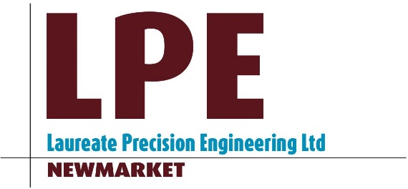

MISSION STATEMENT

1- To produce high quality machined components using our skill and knowledge to the very best of our abilities, and at fair and market competitive prices.

2- Strive to meet all customer delivery deadline to the best of our abilities.

3- Build a good, solid working relationship with all our customers through integrity, honesty, and fairness, using our relationship with suppliers, subcontractors and professional associates.

4- To provide our employees with an honest, safe, and helpful working environment, where every employee can dedicate themselves to providing our customers with exceptional workmanship, exceptional service, and professional integrity.

Issue 1 – 13/3/17
Written by – Paul Woor

